SESSION-3 Introduction to SDLC + V-model
Q-1. Draw the V-Model diagram on paper or using any digital tool, and clearly label each phase with both the developer and tester roles involved at each step.
Ans.
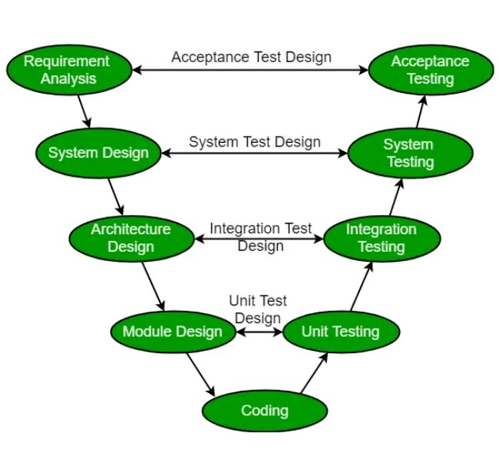
Q-2. Pick any app you use daily (like Zomato, Instagram, or Paytm) and write a short table mapping each SDLC phase (Requirement, Design, Coding, Testing, Deployment, Maintenance) to a real activity that would happen for that app.
Ans.
Example: Zomato App
SDLC Phase | Real Activity in Zomato
Requirement | Product team gathers requirements for a new feature, such as allowing users to schedule food orders for a future date and time.
Design | UI/UX designers create wireframes and screen designs showing how users can select a delivery date and time during checkout.
Coding | Developers build the scheduling functionality, create APIs, update the database, and implement the user interface.
Testing | QA testers verify that scheduled orders can be created, modified, and processed correctly, and check edge cases such as invalid dates or restaurant availability.
Deployment | The new scheduling feature is released to production through app updates and backend deployment so customers can start using it.
Maintenance | The team monitors user feedback, fixes bugs, improves performance, and updates the feature based on customer requests and business needs.

Q-3. For each phase of the V-Model, list one specific testing activity that should be performed, using examples from a food delivery app (like Swiggy or Zomato).Hint: For example, during 'System Testing', you might test if the order placement works end-to-end.
Ans.
V-Model Testing Activities for a Food Delivery App
V-Model Phase | Testing Activity | Example (Food Delivery App)
Business Requirements → Acceptance Testing | Validate business requirements with stakeholders and end users. | Verify that users can place an order, track delivery, and receive the food within the promised workflow as specified by business requirements.
System Requirements → System Testing | Test the complete application end-to-end. | Verify that restaurant selection, cart management, payment, order placement, and order tracking work together correctly.

Q-4. Compare the V-Model and RAD Model by listing 3 strengths and 2 weaknesses of each, focusing on how testing is handled in both models.
Ans.
V-Model vs RAD Model
Aspect | V-Model | RAD (Rapid Application Development) Model
Testing Approach | Testing activities are planned alongside each development phase. | Testing is performed continuously during rapid prototyping and iterations.
Focus | Verification and validation at every stage. | Fast development with frequent user feedback and testing.

Strengths
- Early Test Planning
  - Test cases and test strategies are created during the requirements and design phases, reducing the chance of missing important test scenarios.
- Strong Traceability
  - Every requirement has a corresponding test activity (e.g., System Requirements → System Testing), making coverage easier to track.
- Higher Product Quality
  - Defects can be identified earlier because testing is integrated throughout the lifecycle rather than being left until the end.
Weaknesses
- Less Flexible for Requirement Changes
  - If requirements change after testing plans are created, significant rework may be needed.
- Testing Can Become Documentation-Heavy
  - Extensive planning, reviews, and documentation may slow down projects with rapidly changing requirements.
RAD Model
Strengths
- Continuous Testing During Development
  - Each prototype is tested and refined quickly, allowing defects to be discovered early through user feedback.
- Fast Feedback Cycle
  - Users review working versions frequently, helping testers identify usability and functional issues sooner.
- Quick Delivery
  - Testing occurs in short iterations, enabling faster releases and quicker validation of business ideas.
Weaknesses
- Risk of Incomplete Testing
  - Due to tight timelines, some regression, performance, or security testing may be overlooked.
- Lower Test Documentation
  - Rapid development can result in less formal test planning and reduced traceability compared to the V-Model.

